**2 .WebApi_Handson**

1. **Code**

using Microsoft.AspNetCore.Mvc;

namespace SwaggerDemoApi.Controllers

{

[ApiController]

[Route("[controller]")]

public class WeatherForecastController : ControllerBase

{

private static readonly string[] Summaries = new[]

{

"Freezing", "Bracing", "Chilly", "Cool", "Mild",

"Warm", "Balmy", "Hot", "Sweltering", "Scorching"

};

[HttpGet]

public IEnumerable<WeatherForecast> Get()

{

return Enumerable.Range(1, 5).Select(index => new WeatherForecast

{

Date = DateTime.Now.AddDays(index),

TemperatureC = Random.Shared.Next(-20, 55),

Summary = Summaries[Random.Shared.Next(Summaries.Length)]

});

}

}

}

**OUTPUT**

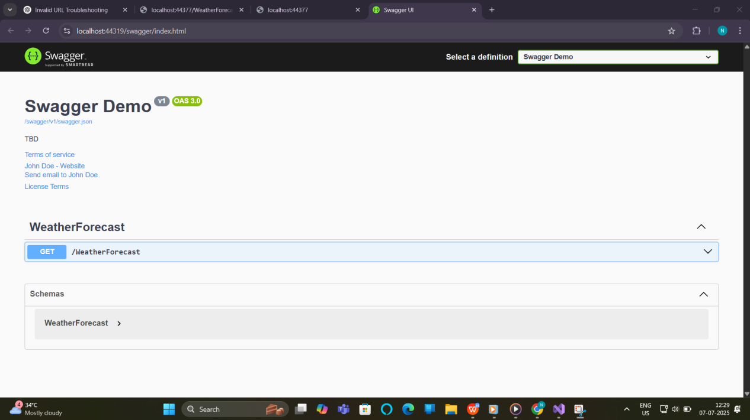

2)

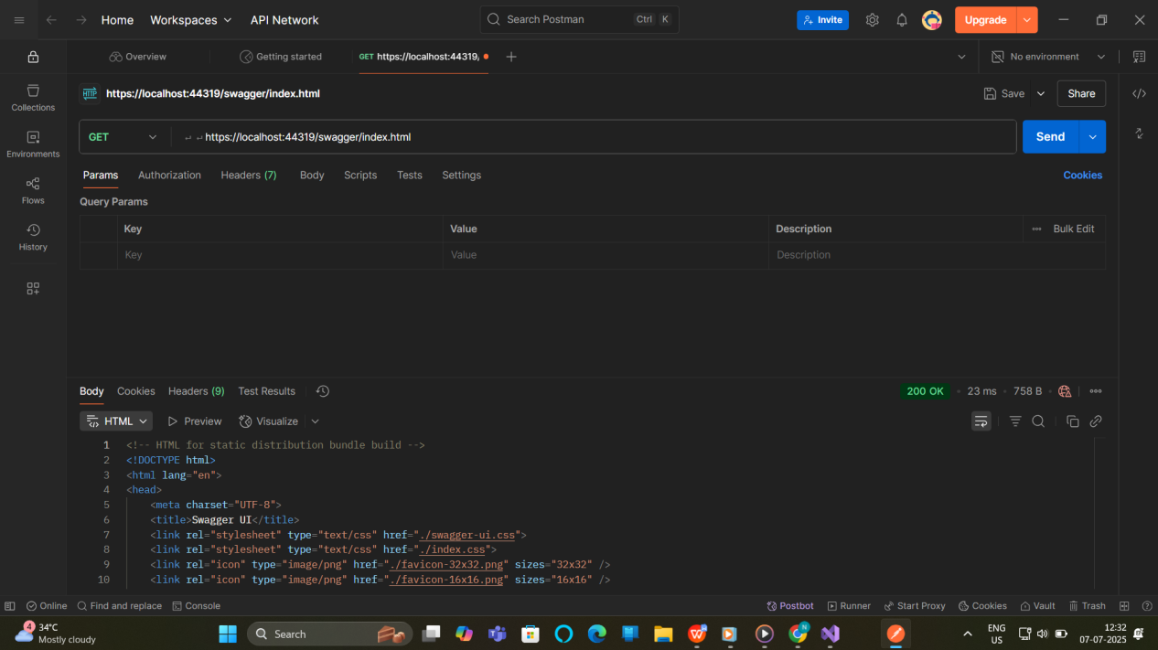

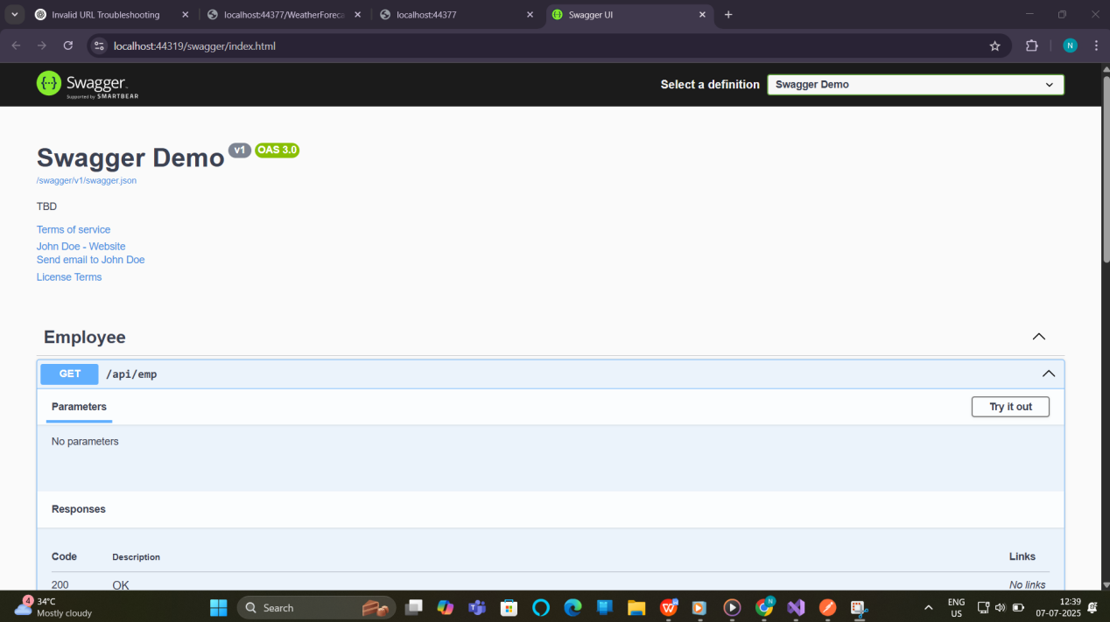

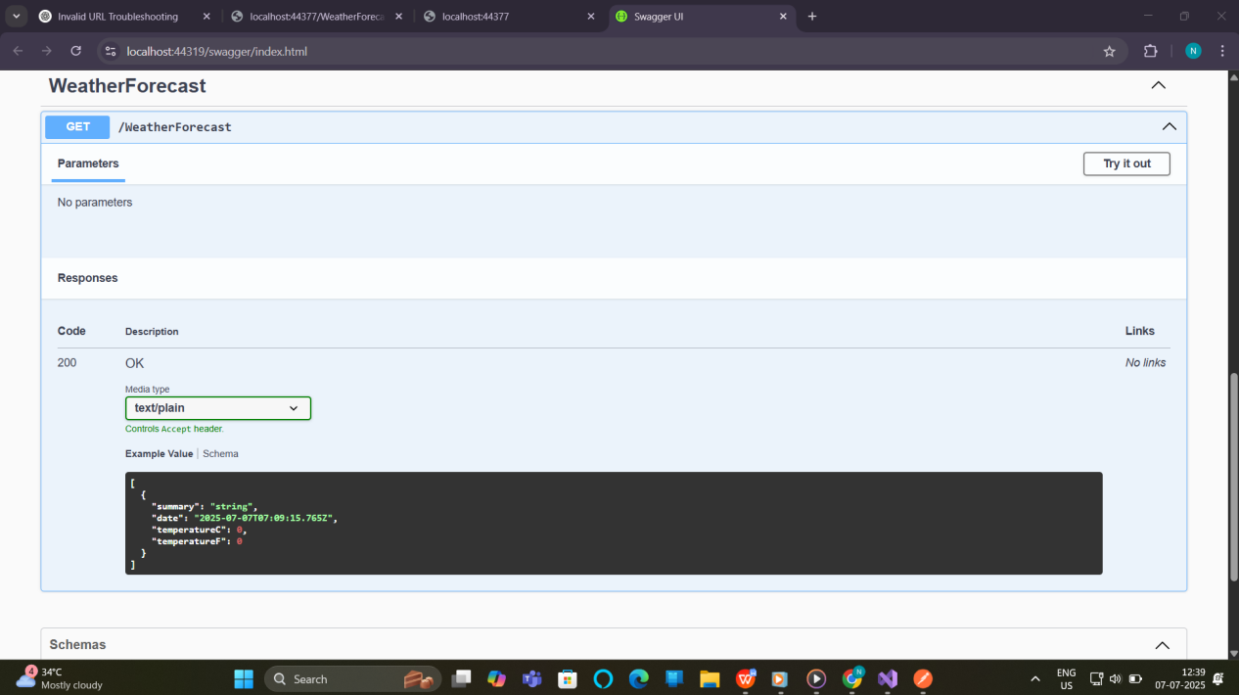

using Microsoft.AspNetCore.Mvc;

using System.Collections.Generic;

namespace SwaggerDemoApi.Controllers

{

[ApiController]

[Route("api/emp")] // Custom route as per instruction

public class EmployeeController : ControllerBase

{

// Sample employee data

[HttpGet]

public ActionResult<IEnumerable<Employee>> GetEmployees()

{

var employees = new List<Employee>

{

new Employee { Id = 1, Name = "Alice", Department = "HR" },

new Employee { Id = 2, Name = "Bob", Department = "IT" },

new Employee { Id = 3, Name = "Charlie", Department = "Finance" }

};

return Ok(employees);

}

}

// Simple Employee model

public class Employee

{

public int Id { get; set; }

public string Name { get; set; }

public string Department { get; set; }

}

}

Program.cs

using Microsoft.OpenApi.Models;

var builder = WebApplication.CreateBuilder(args);

// Add services to the container.

builder.Services.AddControllers();

// Add Swagger services

builder.Services.AddSwaggerGen(c =>

{

c.SwaggerDoc("v1", new OpenApiInfo

{

Title = "Swagger Demo",

Version = "v1",

Description = "TBD",

TermsOfService = new Uri("https://example.com/terms"),

Contact = new OpenApiContact

{

Name = "John Doe",

Email = "john@xyzmail.com",

Url = new Uri("https://www.example.com")

},

License = new OpenApiLicense

{

Name = "License Terms",

Url = new Uri("https://www.example.com")

}

});

});

var app = builder.Build();

// Configure middleware

if (app.Environment.IsDevelopment())

{

app.UseSwagger();

app.UseSwaggerUI(c =>

{

c.SwaggerEndpoint("/swagger/v1/swagger.json", "Swagger Demo");

});

}

app.UseHttpsRedirection();

app.UseAuthorization();

app.MapControllers();

app.Run();